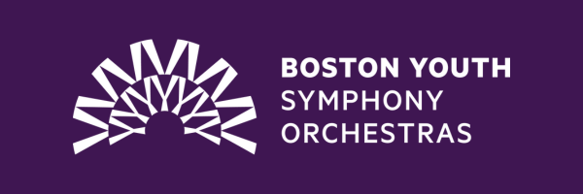

To purchase tickets to attend one of our BYSO concerts held this season at the Boston Children’s Museum, all you need to do is purchase an admission ticket to the Museum. Tickets can be purchased in advance or on the day of. This ticket will allow you access to the museum per normal, but also the chance to see our talented musicians perform!

To purchase a ticket now, visit [Reserve Tickets - Boston Children's Museum (](https://bostonchildrensmuseum.org/ticketing/)[bostonchildrensmuseum.org](http://bostonchildrensmuseum.org)[)](https://bostonchildrensmuseum.org/ticketing/).

**Please note, for BYSO parents and families of students performing, there are special instructions on tickets for this performance. Please review communications from the BYSO operations and marketing teams and contact** [**cjury@bu.edu**](mailto:cjury@bu.edu) **with any questions.**

We hope to see you there!